Date: January, 2026
To: Melissa Carter, Portfolio Manager
From: Jessy Dahl, Portfolio Sales and Marketing Manager
Re: Brickstone; Boulder Communities Leasing and Marketing Strategy
_______________________________________________________________________________________________________
INTRODUCTION:

This memo provides a comprehensive review of the 2026-2027 preleasing cycle for the Boulder Communities (Brickstone), including Mountainaire, The Lodge, The Mansion, Parker Off Pearl, Gaslamp and East Village Flats, identifying key successes and challenges that led to our current occupancy status. It outlines a proactive, data-driven go-forward plan for the upcoming 2026-2027 cycle, designed to achieve our occupancy goals and ensure the community's financial health and success. This strategy focuses on aggressive, phased leasing efforts, strategic pricing, and targeted marketing investments.

The upcoming leasing cycle presents a critical opportunity to course-correct and achieve our financial and operational goals. The proposed plan is a direct response to the key learnings from the prior year and provides a clear, actionable roadmap for success. I am confident that with these strategic adjustments and the necessary resources, we can position each Boulder community for a successful and profitable year.

Upon analyzing The Boulder team’s Key Performance Indicators to identify market, pricing, demographic and leasing trends, I recommend the leasing and marketing strategy outlined in this memo to improve the communities overall leasing performance.

SUMMARY:
Utilizing the data presented in this memo below it has been determined that we have a strategic marketing outreach, community upkeep, and lead to lease conversion efficiency at most of the Boulder communities. To increase performance in these categories we are recommending:

- Improved Team Member Staffing Strategy
  - The Boulder team is experiencing a critical challenge due to insufficient staffing, which is directly impacting their operational efficiency and ability to execute core responsibilities. This shortage is most acutely felt in two areas: leasing and maintenance. In the leasing department, a limited bandwidth stemming from high tour volume is preventing the team from conducting timely follow-ups and effectively clearing their digital dashboard, which is a major contributor to the extremely low conversion rates. Simultaneously, there is a distinct lack of staffing in the maintenance department, leading to backlogs that negatively affect resident satisfaction and the overall condition of properties, such as maintenance request concerns regarding appliances and general pest control. Addressing these staffing gaps is essential to improve conversion and resolve existing resident-facing issues that are hindering leasing success.
- Improve Lead and Application Conversion
  - Address the extremely low conversion rate from Guest Cards to Applications (currently 9–12%).
  - Fix the unacceptable Application to Lease conversion performance, particularly at Mansion, Parker Off Pearl, and East Village Flats, which are near 0%.
  - Diagnose the root cause of conversion failure, such as follow-up timing, pricing shock, or an on-site execution gap.
  - Prioritize overcoming the conversion obstacle before increasing spending on higher ILS packages.
  - Develop and implement specific changes at each underperforming property to correct conversion failures within 30–45 days.
- Address Property and Pricing Issues
  - Address maintenance request concerns, including appliances (East Village Flats and The Lodge), flooring (Parker Off Pearl), heating problems, and general pest control issues.
  - Overcome the pricing objection, which is a major leasing obstacle, especially at Gaslamp.
  - Create a clear, data-backed plan to fully lease the remaining 2BR floorplans at Mountainaire.
  - Develop concrete recommendations and new tactics to drive leasing velocity at Gaslamp due to a noted lack of urgency and proactive ideas from the leasing team.
- Improve Operational Efficiency
  - Address the limited bandwidth for follow-ups due to a large volume of tours, which prevents the team from clearing the dashboard and conducting follow-ups fast enough.
  - Fill the lack of staffing in the maintenance department.
  - Find a solution for leads who are annoyed by follow-ups with the same questions across different communities in the portfolio.
  - For the team to conquer weekly lead audits for each community, identify key objections and opportunities, and close on any and all true leads to improve and enhance conversions to at least 25% (lead to lease conversion benchmark).
  - Prioritize maintenance and upkeep improvements to address the primary resident feedback, improving the overall resident confidence in the community score and ensuring the on-site experience matches the strong digital voice.
  - Prioritize hiring a Marketing Manager with portfolio marketing experience preferred. The team is in need of available staffing - especially when it comes to completing marketing tasks thoroughly, consistently and strategically.
  - Capitalize on the strong, competitive market positioning by focusing sales training on value proposition and experience rather than just rate, to drive conversions from the increased lead flow.

The overall market analysis for the Boulder team concludes that the portfolio is facing a critical challenge due to extremely low conversion rates in a market with increased competition and high vacancy rates. Conversion is the Primary Constraint
The most significant issue is the extremely low conversion from Guest Cards to Applications, which sits at approximately 9–12% across the portfolio—a figure materially below what is required to drive successful leasing velocity.12
- Post-Application Breakdown
The conversion rate from Application to Lease is unacceptable at several properties, notably Mansion (0%), Parker Off Pearl (0%), and East Village Flats (6%). At The Mansion, specifically, a high Guest Card to App conversion (55%) that results in zero leases strongly indicates a breakdown after the application stage, likely due to issues with screening, lease execution, or the closing process.12
- Market Competition and Pricing
The broader market is challenging due to "too many communities in the market" and a "29% loss of vacancy," compounded by the University of Colorado (CU) building more on-campus housing. This has resulted in price-sensitivity becoming a common leasing objection, with some of the portfolio's properties having higher prices compared to competitors.
- Strategic Action
The immediate and crucial focus for the team is to diagnose the specific root cause of the conversion failures and implement a property-specific diagnosis and corrective plan to show measurable progress within 30–45 days. It is advised that a material increase in marketing spend (ILS packages) should be held off until the execution and closing problems are clearly resolved.

Once the below recommendations have been approved we will do the following to ensure execution and follow-through with these items:
- Execute the 30-Day Strategy with a focus on high-impact initiatives like the CU Housing Fair, Mountainaire + Lodge Open House, and consistent on-campus marketing to secure 100+ guest cards in Week 1 alone and leverage digital marketing heavily during holiday periods to convert as many into approved leases to close the YOY prelease gap.
- Work alongside CX3 to implement a full suite of personnel training, including CWOL 4.0 Refresher, Pipeline Management, and Tour/Greeting Etiquette, to ensure a proactive approach to follow-up and a more personable on-site experience that aligns with the strong social media presence.
- Leverage the new Portfolio, Community, and Leasing/Marketing Manager leadership to immediately address the building and amenity maintenance issues identified in the resident feedback analysis to drive an improvement in the ORA score and overall resident confidence in the community’s value.

LEAD CONVERSION

- Lease Conversion
  - The average conversion rate from lead to lease for the past quarter is as follows:
    - Mountainaire: 87 leads, 2 converted leases = 2.3% conversion rate
    - Lodge: 117 leads, 6 converted leases = 5.1% conversion rate
    - Parker Off Pearl: 20 leads, 0 converted leases = 0% conversion rate
    - Gaslamp: 52 leads, 1 converted lease = 2% conversion rate
    - The Mansion: 16 leads, 0 converted leases = 0% conversion rate
    - East Village Flats: 76 leads, 3 converted leases = 4% conversion rate
    - All communities' conversion rates are alarmingly below our Cardinal’s benchmark of 25%. A key learning is the need to enhance our sales training and follow-up processes.

MARKET ANALYSIS
Currently The Boulder communities are at an average of 25.4% preleased. College House data shows that the market as a whole is 9% behind YOY. The communities’ current rate strategy and concession offerings are competitive compared to the market.

Suggested Market Occupancy and Prelease Trends According to College House
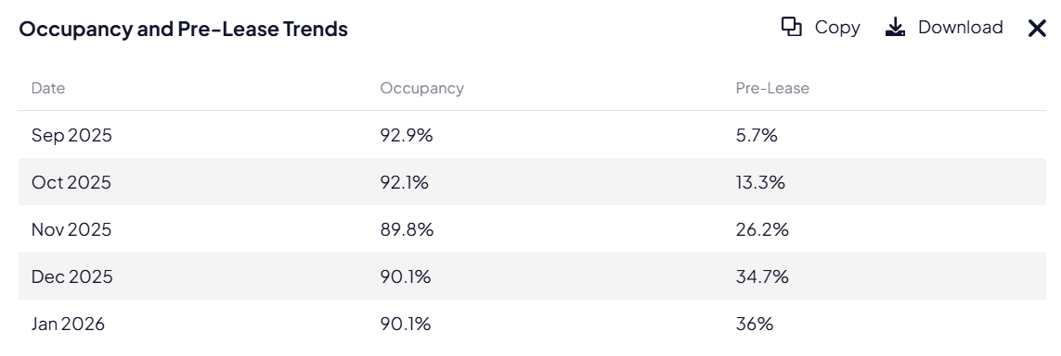

Market Rates (by unit type) According to College House
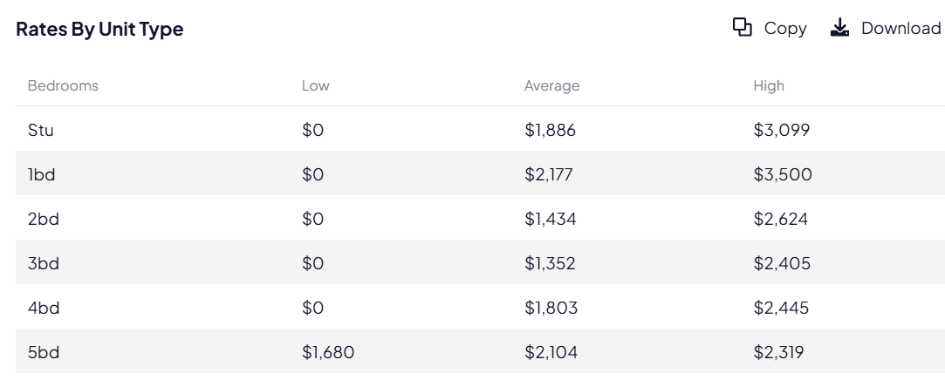

REPUTATION MANAGEMENT
The ORA score for the communities on average is currently 68, a score that has remained consistent over the past three months. Analysis of resident feedback indicates that the primary area for improvement is the maintenance and upkeep of the community's buildings and amenities. Given that reputation significantly influences our leasing strategy, we are confident that the asset's standing will continue to improve with the new Portfolio, Community, and Leasing and Marketing Manager in place. This will ensure that residents and guests recognize the full value of the community.

To "increase awareness with our residents and the public" to clearly differentiate the team and properties from the previous management, which was cited as having "struggles or performance issues". This need for a public break from the past, coupled with the team’s urgent efforts to launch new Reputation Management services (like responding to Google Reviews), suggests the current public perception is either challenged or highly sensitive. Therefore, the team is prioritizing a proactive strategy to rebuild and establish a positive market reputation.

SOCIAL MEDIA STRATEGY
Boulder team’s digital voice and social presence is quite strong; The main opportunity we have is to reflect what prospects see online with what they experience in person. Our recommendations center on the continued implementation of Agency Fifty3 (AF3) core digital services, which are included as part of the Property Management Agreement (PMA). These core services cover Reputation Management (Opinion, ORA), a Design Retainer (Canva subscription), and the overarching Digital Marketing plan (SEO Program, Paid Media, Website, Easytour). A key recommendation is to broaden the social media and website verbiage to appeal to the conventional audience in addition to the student market to increase leasing velocity. Furthermore, the plan includes urgent actions such as creating a Google Form waitlist to be posted on the social media link tree, and on-site team training on platforms such as Canva to support both the new leasing and reputation management efforts.We will implement a high-impact strategy tailored to CU students:

- Key Elements:
  - Target Audience: undergraduate students, graduate students and younger professionals in and around the CU Boulder campus and central Boulder community.
  - Content Focus: Professional photography, reels, interactive stories, and improvement stories
  - Engagement: Respond to all comments and DMs within 24 hours, interact with CU and local business accounts
  - Promotion: Boosts posts on Instagram for more visibility and exposure, tease giveaways on reels and stories to drive traffic, expand to TikTok and Facebook for parent visibility
  - Insights: Track weekly and adjust campaigns monthly
- Goal: To create a brand and story that students are excited to follow and be part of.

Recommendations:
- Enhance Our Special Offers:
  - Tiered Gift Card: We are recommending a higher value gift card of $750 for those who apply and sign within 72 hours.
  - Amenity-Based Specials: Since The Arlie offers free covered parking, we are recommending to offer free parking for the next 20 leases that apply and sign within 72 hours.
- Targeted Marketing Campaign: Develop a specific marketing campaign highlighting the value of each Boulder communities’ floor plans and amenities.
- Showcase Unit Enhancements: Enhance the presentation of each floor plan units during tours.
- Leasing Team Focus: Equip the leasing team with the knowledge and tools to effectively promote each communities’ highlighted units.
LEASING STRATEGIES - CONTINUED
In addition to on-campus efforts to target students, we must aggressively pursue university departments and local business partnerships from now until May, especially now that students are actively searching for housing options.ss
- Lead Audits: Complete 1 weekly. Contact all active leads in Entrata via call, text, and email. Cancel/archive stale leads.
- Email Marketing: Utilize internal university email lists and source new targeted lists (ex: Spring admits, transfers).
- Campus Department Partnerships: Visit student organizations and departments. Send targeted messages via email and social. Align outreach with dorm assignment timelines.
- Hotel Partnerships: Table at hotels, offer discounts, and distribute welcome kits.
- Orientation Campaigns: Align digital and physical ads with university orientation schedules.
- Roommate Matching: Reach out to partially filled units to accelerate full unit leases.
- Referral Growth: Create and promote community referral offers, leveraging residents and comps.
- Team Communication: Host consistent weekly meetings.
- Follow-Up: Shift to more aggressive follow-up cadence and tracking.
- Virtual Engagement: Host Instagram Lives, roommate mixers/open houses at the Clubhouse, and virtual tours.

REPUTATION MANAGEMENT
The Boulder communities currently hold an average ORA score of 61 (Mountainaire at 56, Lodge at 51, Mansion at 68, East Village Flats at 64, Gaslamp at 58, Parker Off Pearl at 67).. Recurring complaints highlight issues with pest infestations and cleanliness, frequent infrastructure fallouts like flooring issues and maintenance lag time, restrictive parking and towing policies, unsatisfactory management responsiveness, and communication. These issues collectively contribute to resident dissatisfaction and pose a risk to attracting new prospects and future residents.
A strong online reputation, reflected in a high ORA score, is essential for the Boulder team communities’ leasing success. Communities with higher ORA scores tend to achieve faster lease-up rates and stronger rent growth. To address the declining ORA score and im
prove overall reputation, the following actions are strongly recommended:
- Address Core Issues Identified in Feedback:
- Maintenance & Infrastructure: Prioritize repairs and upgrades to critical infrastructure, such as elevators and plumbing. Improve communication regarding maintenance schedules and delays.
- Parking & Towing: Review and revise the towing policy to be more reasonable and resident-friendly. Clearly communicate parking rules and permit requirements.
- Management & Communication: Ensure proper customer service training has been rolled out with all management team members, focusing on responsiveness, empathy, and effective communication. Implement a system for tracking and resolving resident complaints.

By implementing these reputation management tools and services, the Boulder communities as a whole can take proactive steps to improve its ORA score, enhance its online reputation, and ultimately drive leasing success.
SUMMARY OF LEASING & MARKETING RECOMMENDATIONS - NEED APPROVAL
- Re-stratetized Staffing Plan: In the leasing department, a limited bandwidth stemming from high tour volume is preventing the team from conducting timely follow-ups and effectively clearing their digital dashboard, which is a major contributor to the extremely low conversion rates. Addressing these staffing gaps is essential to improve conversion and resolve existing resident-facing issues that are hindering leasing success.
- Aggressive Leasing Strategies: Implement and intensify leasing efforts to expand reach beyond the immediate area, including higher, more aggressive specials.
- Strategic Pricing Adjustments/Concessions: Evaluate and adjust four-bedroom floor plan pricing and offer targeted concessions (ex: rent credits or gift cards) to enhance competitiveness.
- Enhanced Marketing and Outreach: Optimize digital marketing spend and execute targeted outreach to key lead sources, focusing on highlighting the value of each community’s highlighted floor plans/units.
- Improved Lead Management and Team Performance: Enhance lead follow-up, provide training on closing techniques, and address performance concerns within the leasing team.

SPECIAL RECOMMENDATIONS - NEED APPROVAL

The special recommendations for the Boulder team are primarily centered on aggressive leasing incentives and tactical marketing adjustments to immediately address the critical conversion gap. The core strategy is a proposed "FLASH SALE" for properties like Mansion, Gaslamp, and Mountainaire, which includes offering significant concessions such as ONE MONTH FREE RENT, a year of FREE PARKING, and additional incentives for filling an entire unit, based on team feedback that free rent is preferred over gift cards. Furthermore, a key recommendation is to hold off on spending more funds on higher ILS packages because the fundamental problem is conversion, not a lack of lead volume. Instead, the team is executing digital marketing changes, including updating the main website banners to feature "PICK YOUR PERK SPECIAL" promotions, and working to prominently display self-guided tours to improve the lead experience. There is also a push to acquire various branded promotional items for marketing events and to compile a list for a property refresh at The Lodge to maintain competitiveness

4-WEEK LEASING STRATEGY
In addition to the weekly social media posts, follow-ups, call banks, and e-blasts, the Boulder team will initiate the following initiatives weekly.

Below is a 4-week leasing strategy broken into a Monday - Friday format, starting Monday, January 12, 2026, and running through Friday, February 13, 2026. This includes:

- Weekly Lead Audit for all six communities
- Weekly Outreach to local businesses
- Weekly Outreach to campus and campus departments (assorted by week)
- Building partnerships with local businesses
- Interactive social media posts via feed, stories and Reels
- University-specific key dates

(PSM will ensure the items below will be checked off the next 30 days)
- Boulder January MMP
- 90-Day Marketing Plan (INCENTIVES - NEED OPS/CLIENT APPROVAL)
- Social Media Plan - Jan Through July

